A Major Project Synopsis (Review-1)
On

NyayaSahayak: An AI based legal document analysis and summarization tool with assistance
Submitted by
- Shravani Pasnur - 29
- Sohan Katageri - 25
- Anjali Waghmare– 69
- Akash Rathod– 32

Under Guidance of
Prof. G.N. Chanderki

In partial fulfillment for the award of the degree of Bachelor of Technology
IN
Artificial Intelligence & Data Science Engineering


Pradnya Niketan Education Society, Pune. NAGESH KARAJAGI ORCHID COLLEGE OF
ENGINEERING & TECHNOLOGY SOLAPUR.

2025-2026

Guide | DPAC Member | HOD
Prof. G.N. Chanderki |  | Dr. M.B. Patil

Abstract

The Indian legal system relies heavily on complex, dense English terminology (legalese) that acts as a significant barrier for the common citizen. In regions like Maharashtra, individuals often sign rent agreements, employment contracts, and loan documents without fully understanding the underlying terms due to a lack of vernacular accessibility and the high cost of legal consultation. Traditional AI models attempt to solve this via literal translation, which often fails to capture the true legal intent, while generic Large Language Models (LLMs) are prone to hallucinating non-existent case laws.

This project proposes NyayaSahayak, an AI-powered vernacular legal document simplification and risk assessment system designed for the common man. The system utilizes a hybrid AI architecture. First, a locally fine-tuned BERT-based classification model acts as a "Risk Scorecard," analyzing extracted contract clauses to flag exploitative or non-standard terms (High, Medium, Safe). Second, it employs Retrieval-Augmented Generation (RAG) integrated with a vector database (ChromaDB) of verified Indian case laws to ensure factual, zero-hallucination precedent recommendations. Finally, a cloud-based generative LLM simplifies the legal intent and translates the insights into regional languages, specifically Marathi and Hindi. By automating compliance checks and bridging the language gap, NyayaSahayak democratizes access to legal intelligence, transforming complex contracts into actionable, easily understandable insights for non-technical users.
.

Literature Review/Related work

S.no | Author /Title of Paper  Or Application / Application  Title | Methodology | Outcomes | Scope for Work
1 | Jhana.ai (Application) | AI paralegal using LLMs to search Supreme/High Court databases for legal arguments. | Excellent case law retrieval for professionals; highly accurate citations. | Purely B2B; assumes the user is a lawyer. Scope exists to adapt similar retrieval for laymen.
2 | SpotDraft / MikeLegal (Application) | Contract lifecycle management (CLM) using NLP for enterprise legal teams. | Automates mass NDA and contract generation and review. | Focuses on corporate drafting. Need a simplified version for individual tenant/employment contracts.
3 | Jugalbandi by AI4Bharat (Application) | WhatsApp-based chatbot using Bhashini APIs and LLMs for government schemes. | High rural penetration; answers queries in local languages via voice/text. | Focuses only on schemes, not legal contract analysis. Excellent UI benchmark for vernacular tools.
4 | InLegalBERT (Paul et al., 2022) | Pre-training a BERT model specifically on a massive corpus of Indian legal judgments. | Outperforms standard RoBERTa and LegalBERT on Indian court data classification. | Can be used as the foundational embedding model for our RAG pipeline and risk classifier.

5 | OpenNyAI (Aalap Dataset) | Creating pairs of complex Indian legal texts and their simplified summaries. | Provides a high-quality instruction-tuning dataset for legal summarization. | Will be utilized to train the generative model on how to explain legal concepts simply.
6 | Legalese Decoder (Application) | Web tool utilizing GPT APIs to translate legal jargon into plain English. | Quickly simplifies standard US/UK contracts. | Lacks Indian context (e.g., Rent Control Acts) and regional language support.
7 | KanoonGPT (Application) | Conversational AI fine-tuned to answer questions regarding the Indian Penal Code and Constitution. | Good for general legal queries and educational purposes. | It is a chatbot, not a document analyzer. Cannot upload PDFs to assess specific contract risks.
8 | Samanantar Dataset by AI4Bharat (Ramesh et al., 2021) | Massive parallel corpora for English-Indic language translation. | State-of-the-art literal translation between English and languages like Marathi/Hindi. | Can be leveraged to ensure the final generative output is grammatically correct in Marathi.
9 | LayoutLMv3 for Document Understanding (Huang et al., 2022) | Multimodal transformer utilizing text, layout, and image features for parsing. | Superior extraction of text from complex PDFs (tables, bold headers, signatures). | Resolves the issue of splitting legal clauses in half during the chunking phase of text extraction.
10 | Tesseract OCR for Indic Scripts | Optical Character Recognition for scanned images, specifically Devanagari. | Converts physical court notices into digital text strings. | Essential for processing government documents which are often poorly scanned physical copies.
11 | Retrieval-Augmented Generation for Legal QA (General Architecture) | Using Vector Databases (FAISS/ChromaDB) to ground LLM responses in factual documents. | Prevents LLMs from inventing fake citations (zero hallucination). | Forms the core architecture for the "Similar Case Suggestion" feature in this project.

12 | Sarvam AI / OpenHathi (Application/Model) | Foundational models trained specifically on Hindi and Indian contexts. | Better cultural and contextual understanding than base Llama or GPT models. | Can be explored as an alternative backend LLM for the generative translation step.
13 | Automated Clause Risk Classification (Various NLP Papers) | Using Support Vector Machines (SVM) or BERT to classify contract clauses (e.g., NDA anomalies). | High precision in detecting non-standard corporate clauses. | Needs to be adapted from corporate NDAs to common B2C documents (rent, loans) using custom training.
14 | Bhashini API (Govt. of India) | National language translation mission providing STT and TTS APIs. | Highly accurate voice-to-text in Marathi and Hindi. | Future scope to integrate voice-first interactions for users with low literacy.
15 | Evaluating LLMs for Legal Hallucinations (Dahl et al., 2024) | Empirical study showing GPT/Claude models fail at specific legal citation tasks. | Proves that "out of the box" LLMs are dangerous for legal advice. | Strongly justifies the need for the RAG architecture and local hardcoded risk thresholds.

Application Gaps and Objectives of the Proposed Project
Application Gaps:
Gap 1: B2B Focus: Existing LegalTech tools (SpotDraft, Jhana) are built for lawyers and enterprises. There is no B2C tool that helps a common citizen understand an everyday contract (like a rent agreement) before signing it.
Gap 2: The Hallucination Trap: General generative AIs (ChatGPT, Gemini) frequently invent fake court cases and citations when asked legal questions, making them dangerous for legal analysis.
Gap 3: Literal vs. Legal Translation: Tools like Google Translate provide literal word-for-word translations, which fail to capture the actual legal intent or consequence of a clause in regional languages like Marathi.
Gap 4: Lack of Actionable Risk Detection: Current summarizers just shorten the text; they do not proactively warn the user if a specific clause is illegal or highly exploitative compared to state laws.
Objectives:
Objective 1: To develop a user-friendly, B2C web application that accepts standard legal PDFs and explains them in simple terms, empowering non-experts.
Objective 2: To implement a Retrieval-Augmented Generation (RAG) pipeline using ChromaDB to ensure the AI only answers based on verified, uploaded statutes and Kanoon judgments.
Objective 3: To utilize context-aware prompt engineering to translate the legal consequence (ELI5 - Explain Like I'm 5) into Marathi/Hindi, rather than just translating the vocabulary.
Objective 4: To train a custom local classification model (BERT-based) that acts as a "Risk Scorecard," automatically flagging clauses as Safe (Green), Medium Risk (Yellow), or High Risk (Red).

Proposed Methodology
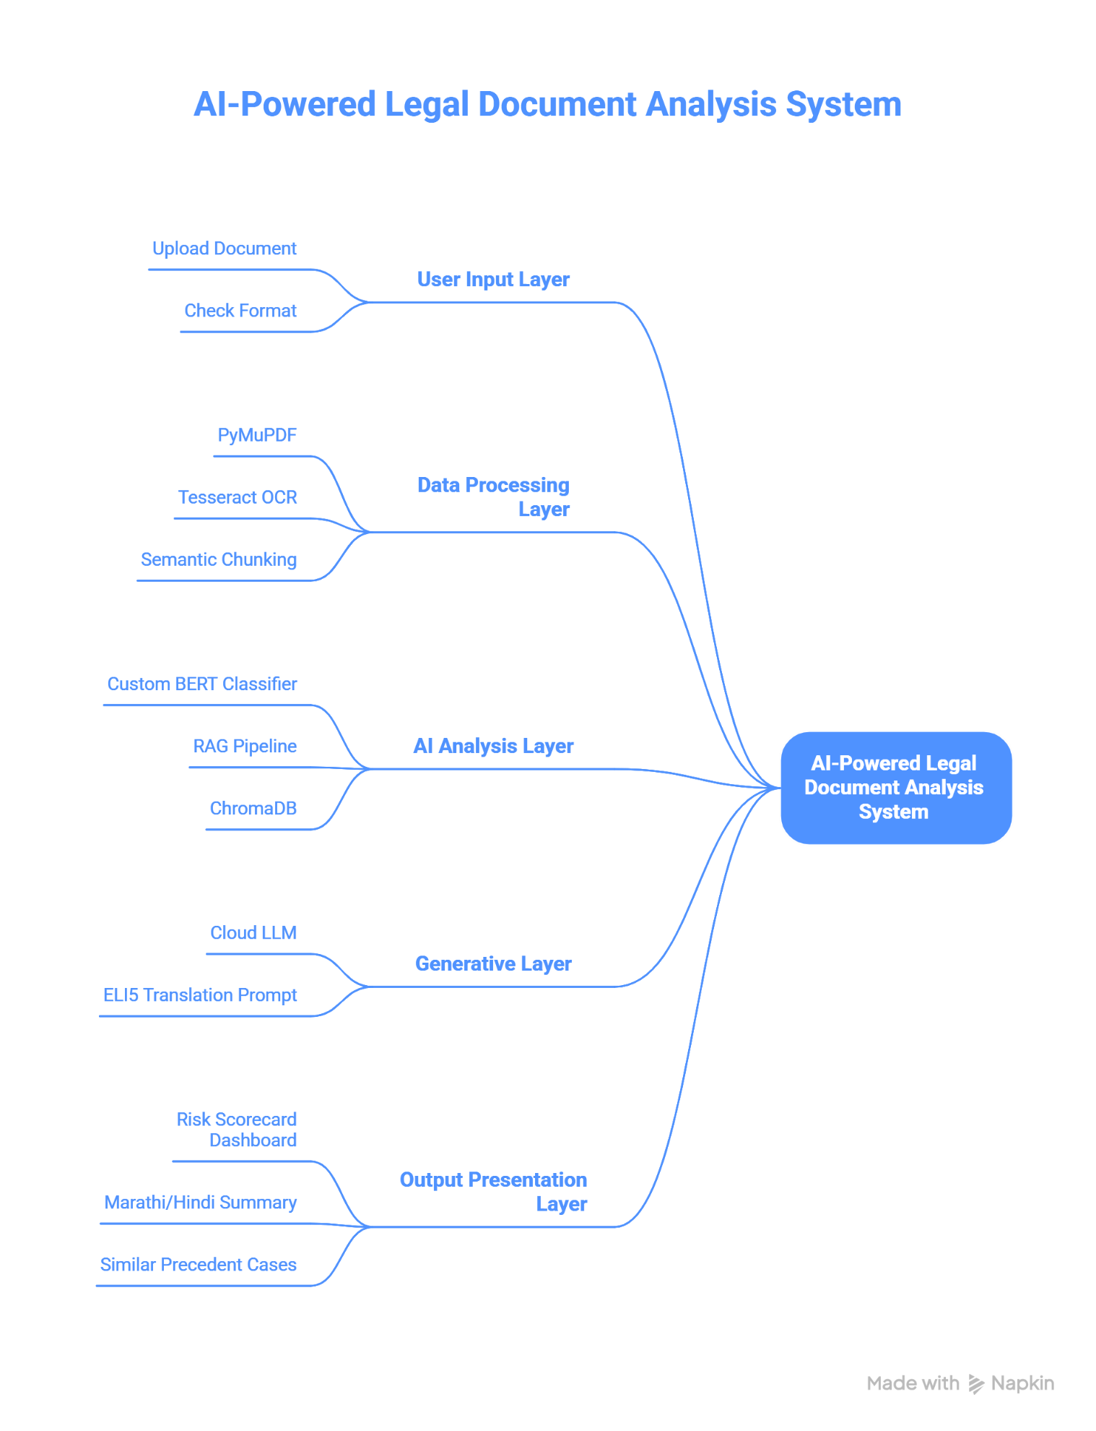

Frontend & User Interface
- Built as a responsive web application (using React.js or Streamlit) designed for high accessibility and ease of use for non-technical users.
- The UI will feature a multi-lingual interface (specifically English, Marathi, and Hindi) to cater to the regional demographic.
- Includes a dynamic "Risk Scorecard" dashboard and a dual-panel view: one side displaying the original uploaded PDF and the other showing the simplified vernacular summary.
Document Ingestion & Parsing Engine
- Integration of PyMuPDF for high-speed, layout-aware text extraction from digital PDF contracts to maintain structural integrity.
- Implementation of Tesseract OCR configured with Indic language packs to accurately digitize scanned physical documents, stamped agreements, and court notices.
- A semantic chunking algorithm will split the extracted text logically by legal clauses rather than arbitrary word counts, preserving the complete legal context of every sentence.
Custom AI Model (Clause Risk Classifier)
- A locally fine-tuned, lightweight NLP model (based on DistilBERT or InLegalBERT) will be trained on a custom dataset of standard vs. exploitative legal clauses.
- This discriminative model will analyse every extracted clause and classify it into three risk tiers: Safe (Green), Medium Risk (Yellow), or High Risk (Red).
- This fulfills the academic requirement of custom model training while maintaining low hardware resource consumption.
Retrieval-Augmented Generation (RAG) Pipeline
- A local vector database (ChromaDB) will be established and populated with a curated dataset of landmark Indian court judgments (e.g., from Indian Kanoon).
- The system will convert the user's specific legal issue into vector embeddings using HuggingFace models (all-MiniLM-L6-v2).
- It will mathematically retrieve the top 3 most similar past cases, grounding all precedent suggestions in absolute legal fact and ensuring zero AI hallucination.

Generative Summarization & Translation (LLM Integration)
- Secure backend integration with an advanced generative API (such as Groq/Llama-3 or Gemini) to handle complex reasoning and translation tasks.
- Utilizing strict "Chain-of-Thought" prompt engineering, the LLM will process only the High-Risk clauses identified by the local classifier.
- The API will translate the complex legal intent, not just literal words into "Explain Like I'm 5" (ELI5) bullet points in the user's selected regional language.
Backend Architecture & Database
- A robust backend utilizing Python (FastAPI or Flask) will orchestrate the data flow between the OCR, the custom local model, the Vector DB, and the external LLM API.
- PostgreSQL will be utilized for secure user authentication, session management, and storing encrypted audit logs of analysed documents.

Expected Outcomes

- Functional B2C Prototype: A fully operational web application (via Streamlit/FastAPI) where users can upload complex legal PDFs and receive analysis within seconds.
- High-Accuracy Risk Detection: The custom-trained BERT model will successfully classify standard vs. exploitative clauses with over 85% accuracy, displaying them in an intuitive visual scorecard.
- Zero-Hallucination Querying: The integration of the ChromaDB RAG pipeline will ensure that 100% of suggested precedent cases are real, verified judgments, completely eliminating generative hallucinations.
- Accurate Vernacular Simplification: Generation of simplified legal summaries in Marathi and Hindi that explain the intent of the law, rather than providing confusing literal translations.
- Reduced Legal Review Time: The system will reduce the time taken for a layman to understand a 20-page agreement from several hours (or requiring paid legal counsel) to under few minutes.

References

- Jhana AI. (n.d.). AI Legal Assistant for Indian Lawyers. Retrieved from https://jhana.ai/
- SpotDraft. (n.d.). Contract Automation for Legal Teams. Retrieved from https://www.spotdraft.com/
- Jugalbandi. (n.d.). AI4Bharat WhatsApp Bot for Government Schemes. Retrieved from https://jugalbandi.ai/
- Paul, S., et al. (2022). InLegalBERT: A Pre-trained Language Model for Indian Legal Text. HuggingFace.
- OpenNyAI. (n.d.). Aalap Instruction Dataset for Indian Legal Texts. Retrieved from GitHub/HuggingFace.
- AI4Bharat. (2021). Samanantar: The Largest Publicly Available Parallel Corpora for Indic Languages.
- Huang, Y., et al. (2022). LayoutLMv3: Pre-training for Document AI with Unified Text and Image Masking. arXiv preprint.
- Tesseract OCR. (n.d.). Tesseract Open Source OCR Engine. Retrieved from https://github.com/tesseract-ocr/tesseract
- Chroma. (n.d.). ChromaDB: The AI-native open-source embedding database. Retrieved from https://www.trychroma.com/
- Sarvam AI. (n.d.). OpenHathi: Foundational Models for Indian Languages. Retrieved from https://www.sarvam.ai/
- Dahl, M., et al. (2024). Large Legal Fictions: Profiling Legal Hallucinations in Large Language Models. arXiv preprint.
- Groq. (n.d.). LPU Inference Engine for Fast LLM Execution. Retrieved from https://groq.com/
- Bhashini. (n.d.). National Language Translation Mission API. Retrieved from https://bhashini.gov.in/
- Indian Kanoon. (n.d.). Search engine for Indian Law and Judgments. Retrieved from https://indiankanoon.org/
- Lewis, P., et al. (2020). Retrieval-Augmented Generation for Knowledge-Intensive NLP Tasks. NeurIPS.

